Research Article

Retention and Quality of Life Outcomes of Zygomatic Implants vs. Conventional Removable Obturators in Post-Maxillectomy Defect Rehabilitation: A Systematic Review and MetaAnalysis

Mubarak Ali^{1*}, Abdul Manan Hasni², Ajmal Khan³, Shahzad Nasir⁴, Omer Bashir⁵, Fareed Ahmad⁶
^{1*}Consultant Oral and Maxillofacial Surgeon and SCHFS Classified Senior Registrar. In-charge, Dental Block, Civil Hospital, Madyan, Swat, Pakistan.
²Shahida Islam Dental College, Pakistan.
³Associate professor, Department of Oral & Maxillofacial Surgery, Saidu College of dentistry, Swat, Pakistan
⁴Assistant Professor, Department Oral and Maxillofacial Surgery, Margalla institute of health sciences Rawalpindi, Pakistan.
⁵Asst Professor, Oral and Maxillofacial Surgery. Rehman College of Dentistry, Peshawar, Pakistan.
⁶Khyber Medical University Institute of Dental Sciences, Kohat, Pakistan.
Email: ^{1*}drmubarakalikcd@gmail.com, ²abdulmannanhasni699@gmail.com, ³ajmal1172@gmail.com, ⁴dr_shahzadnasir2000@yahoo.com, ⁵dromerbashir@hotmail.com, ⁶fareedriaaz@gmail.com
Corresponding Author: Mubarak Ali
^{1*}Consultant Oral and Maxillofacial Surgeon and SCHFS Classified Senior Registrar. In-charge, Dental Block, Civil Hospital, Madyan, Swat, Pakistan.
drmubarakalikcd@gmail.com
Received: 28.09.2026, Revised: 03.10.2026, Accepted: 05.10.2026

ABSTRACT
Background: Rehabilitation after maxillectomy requires closure of the defect and restoration of oral function. Zygomatic implants can provide anchorage for an obturator, but the comparative effects on retention and quality of life remain uncertain.
Objective: To compare retention and quality-of-life outcomes of zygomatic implant-retained obturators with those of conventional removable obturators in patients with maxillectomy defects.
Methods: Comparative clinical studies in patients after maxillectomy were eligible. Direct evidence compared zygomatic implant retained or supported obturators with conventional removable obturators; broader midfacial implant comparisons were retained as indirect evidence. Web and publisher searches were recorded through 3 October 2026. One reviewer selected studies, extracted data and assessed nonrandomized comparisons with ROBINS-I. Findings were synthesized narratively using SWiM reporting principles, and certainty was assessed with GRADE. Structured bibliographic database searches and duplicate review were not performed.
Results: Seventeen reports were assessed; 13 were excluded, two remained awaiting classification in the recorded extraction, and two comparative studies involving 27 unique patients were included. One study directly evaluated zygomatic implants in eight patients; the other compared broader implant supported obturators in nine patients with conventional obturators in ten. Neither directly measured retention. The eight patient study reported an OHRQoL impact score of 0.173 ± 0.187 with the zygomatic obturator versus 0.519 ± 0.168 with the conventional obturator (lower is better; reported p < 0.01). Masseter and temporalis electromyographic amplitudes increased by 53.4 and 81.85 µV, respectively; all eight implants survived at 12 months of loading. The cross-sectional comparison reported better selected oral function and chewing outcomes with implant support. Both studies had serious risk of bias. Certainty was very low for outcomes with available evidence, and no meta-analysis was performed.
Conclusion: Zygomatic implant retained obturators may improve oral health related quality of life and aspects of masticatory function, but direct comparative evidence is limited to one small nonrandomized study. Broader implant evidence is indirect. Retention superiority and comparative safety have not been demonstrated. The findings require cautious interpretation because searches were restricted, some reports remained unclassified and certainty was very low.

Keywords: Zygomatic Implants, Obturator Prosthesis, Maxillectomy, Maxillofacial Prosthesis, Quality Of Life, Dental Prosthesis Retention.

INTRODUCTION
Maxillectomy for benign or malignant tumours, and more recently for invasive fungal infection, leaves a communication between the oral cavity and the maxillary sinus and nasal cavity. The size and extent of the defect, described by classifications such as that of Brown and Shaw, determine how much tooth, bone and palatal support remains for rehabilitation [1]. Without rehabilitation, patients suffer hypernasal speech, nasal regurgitation of food and fluids, impaired chewing and facial disfigurement.
The removable obturator prosthesis has long been the standard prosthodontic option. It closes the defect and restores the dentition without further surgery, and it allows direct inspection of the resection cavity for tumour recurrence. Its design depends on the remaining teeth and the defect configuration, as described in Aramany's classification [2]. Retention, stability and support are the main limitations of conventional obturators. Retention falls as the defect enlarges and as abutment teeth are lost, and it is poorest in edentulous patients and in bilateral or total maxillectomy. Poor retention leads to leakage, displacement during function and lower quality of life [3]. A meta-analysis comparing obturation with surgical reconstruction found no clear difference in quality-of-life scores, but it did not separate obturators by their method of retention [4].
Zygomatic implants offer remote anchorage in the zygomatic bone, which is usually preserved after maxillectomy and is dense enough to support long implants. They can retain or support an obturator through bars, attachments or magnets, independently of the remaining teeth. A review of zygomatic implant-based rehabilitation of maxillary and midfacial oncology defects reported implant survival of 77% to 100%, with obturator support as the most common use [5]. Recent prospective series have reported high implant survival and favourable patient-reported outcomes after guided placement in head and neck cancer patients [6] and in patients after maxillectomy for mucormycosis [7].
These reports are largely single-arm series. Whether zygomatic implant-retained obturators provide better retention and quality of life than conventional obturators has not been established by a systematic comparison. Zygomatic implant surgery adds cost, operative time and the risk of complications, so the size of any benefit matters for clinical decisions and for counselling patients.
The objective of this systematic review was to compare retention and quality-of-life outcomes of zygomatic implant-retained obturators with those of conventional removable obturators in patients rehabilitated after maxillectomy.

METHODS

Reporting
This manuscript uses the PRISMA 2020 reporting framework [8] and a structured approach to eligibility, extraction, risk of bias and synthesis. Methodological limitations are stated explicitly; complete adherence to standard systematic review methods or a comprehensive search is not claimed. Cochrane methodological guidance informed the interpretation of intervention evidence [9].

Eligibility Criteria
Population: patients of any age with an acquired maxillary defect after partial, subtotal or total maxillectomy for any cause.
Intervention: a removable obturator retained or supported by zygomatic implants, with or without additional conventional implants. Studies using implants placed in the remaining midfacial bone were also eligible when zygomatic sites could not be separated; this was treated as indirectness.
Comparator: a conventional removable obturator retained by clasps, remaining teeth, defect undercuts or soft tissues, without implants.
Outcomes: the primary outcomes were obturator retention assessed objectively or through a dedicated patient reported measure, and health related or oral health related quality of life. Validated instruments were preferred, but available results from an incompletely described OHRQoL instrument were retained with explicit measurement limitations. Secondary outcomes were masticatory function, speech, implant survival and surgical or prosthetic complications.
Study design: randomized trials, non-randomized controlled studies, prospective or retrospective cohort studies, within-patient (crossover or before-and-after) comparisons and comparative cross-sectional studies. Single-arm case series, case reports, reviews, in-vitro and cadaver studies were excluded. Retracted publications were excluded.

Information Sources and Search
Reports were identified through web searching, publisher and journal websites, and open access repositories, with the recorded search date of 3 October 2026. Earlier reviews of zygomatic implant rehabilitation [5] and rehabilitation after maxillectomy [4] were checked for comparative reports; their reference lists were not systematically screened. The queries combined zygomatic implants, obturators, maxillectomy, retention, quality of life and comparative designs. No language or date limits were recorded. Table 1 reproduces the 19 entered queries. The search engine identity, complete retrieval yields and deduplication history were not specified in the record; the 17 report count is an assessed evidence set rather than a reproducible database yield.

Table 1. Recorded Web Search Queries
No | Query as entered
1 | zygomatic implants versus conventional obturator maxillectomy quality of life comparative study
2 | zygomatic implant retained obturator vs conventional obturator retention OHIP-14 Obturator Functioning Scale
3 | systematic review zygomatic implants maxillectomy defects survival rehabilitation
4 | "zygomatic" "obturator" randomized OR cohort "conventional obturator" maxillary defect patient satisfaction EORTC
5 | "Rehabilitation of Maxillectomy Patients Using Zygoma Implants" 2025 cureus OR journal
6 | "Rehabilitation of Maxillary Defect Using Zygomatic Implant Retained Obturator" study
7 | "Zygomatic implants for rehabilitation of head and neck cancer patients: a systematic review and meta-analysis"
8 | zygomatic implant obturator versus conventional obturator retention force Newton digital force gauge maxillectomy
9 | zygomatic implant obturator compared with conventional obturator patients maxillectomy Obturator Functioning Scale study Egypt
10 | implant-retained obturator versus conventional obturator quality of life maxillectomy systematic review meta-analysis
11 | Buurman Vosselman zygomatic implants maxillectomy obturator patient-reported outcome comparison
12 | zygomatic implant supported obturator versus tooth-retained conventional obturator speech mastication retention clinical trial 2022 2023 2024
13 | "Functional and esthetic outcomes of zygomatic implant-supported prosthesis in post-maxillectomy patients"
14 | "Rehabilitation of Maxillectomy Patients Using Zygoma Implants" authors abstract 2025
15 | Buurman 2020 "implant-supported obturators and conventional obturators" masticatory performance OHIP results zygomatic
16 | "Comparative analysis of surgical and prosthetic rehabilitation in maxillectomy" systematic review meta-analysis 2023 authors
17 | zygomatic implant retained obturator versus conventional obturator journals.ekb.eg maxillectomy retention quality of life
18 | 40756924 zygoma implants maxillectomy patients 2025 retrospective obturator outcomes
19 | quad zygomatic OR zygomatic oncology implant obturator "conventional obturator" control group speech intelligibility nasal leakage study

Queries are transcribed from the recorded search on 3 October 2026. Prepared database strategies were not executed and are not counted as searches.

Study Selection
One reviewer assessed titles, abstracts and available reports against the eligibility criteria. Decisions could be based on a full text, abstract, publisher summary or title listing; the basis was recorded for each report. Reports with insufficient information remained awaiting classification. Thus, the exclusion log includes decisions made at different levels of report access and is not described as a full text only screening log. No screening automation was reported.

Data Collection
One reviewer extracted country, study design, patient numbers, defect characteristics, intervention and comparator details, loading protocol, assessment timing, outcome instruments and arm level results. Where the extraction contained only qualitative findings, the reported direction and significance were retained without imputing means, variances or event counts. Study authors were not contacted. Targeted bibliographic checks during manuscript preparation corrected study author labels but did not constitute a systematic search update or independent duplicate extraction.

Risk of Bias
Nonrandomized comparisons were assessed using the seven ROBINS-I domains: confounding, participant selection, intervention classification, deviations from intended intervention, missing data, outcome measurement and selection of reported results [10]. The recorded judgments were made by one reviewer. Outcome measurement was considered separately for self report and objective tests where the source allowed. Overall judgments were retained as serious risk of bias. Lack of a registered protocol limits verification of prespecification but does not, by itself, demonstrate selective reporting.

Effect Measures and Synthesis
Studies were grouped by outcome and by directness of the intervention comparison. Continuous results were presented as reported means and standard deviations, with descriptive mean differences where both conditions were available. Implant survival was described using the observed numerator, denominator and follow-up. No outcome had sufficiently comparable, complete data from at least two studies to support meta-analysis. Narrative synthesis followed SWiM reporting principles [11], emphasizing study design, directness and risk of bias rather than counting statistically significant findings.
The eight participants in Salem 2015 were measured under both prosthetic conditions. Their paired correlation or standard deviation of change was not available in the extraction, so paired confidence intervals could not be reconstructed. The two conditions were not treated as independent samples for inferential effect estimation. Figure 3 displays reported means and standard deviations, which describe the observations rather than confidence intervals for treatment effects. No standardized pooled effect was calculated. Numerical results for Buurman 2020 were not present in the supplied extraction and were not imputed.
No pooled heterogeneity statistic, subgroup meta-analysis or statistical sensitivity analysis was calculated. Small study effect tests and funnel plot interpretation were not appropriate with two studies. Selective publication could not be excluded, and missing numerical outcomes were considered a separate reporting limitation.

Certainty of Evidence
Certainty was assessed by outcome using GRADE considerations of risk of bias, inconsistency, indirectness, imprecision and publication bias [12]. Nonrandomized evidence started at low certainty and was downgraded for the documented limitations. Outcomes not measured were labeled as having no comparative evidence, rather than assigned a certainty rating. The ratings describe the available evidence set and remain vulnerable to incomplete study identification.

Deviations from Planned Methods
Structured searches of MEDLINE, Embase, Scopus, CENTRAL and trial registries were not performed. Selection, extraction and bias assessment were undertaken by one reviewer. Database strategies prepared in the source were not treated as executed searches. The source described a planned meta-analysis, but no registered or published protocol was available to verify prospective specification. Accordingly, analytical decisions are described transparently as the approach used for the current synthesis.

RESULTS

Study Selection
Seventeen reports were assessed in the recorded search set (Figure 1). Thirteen were excluded, and two remained awaiting classification. Exclusions comprised five reports without a conventional obturator comparator, three case reports, two reviews, one conventional implant comparison, one comparison with flap supported fixed prostheses, and one comparison between obturator designs without implants. One single-arm report had also been retracted [16]. Table 2 records the reports, reasons and access basis. Two comparative studies involving 27 unique patients were included [13,14], comprising eight patients measured twice and 19 patients assessed in separate groups.

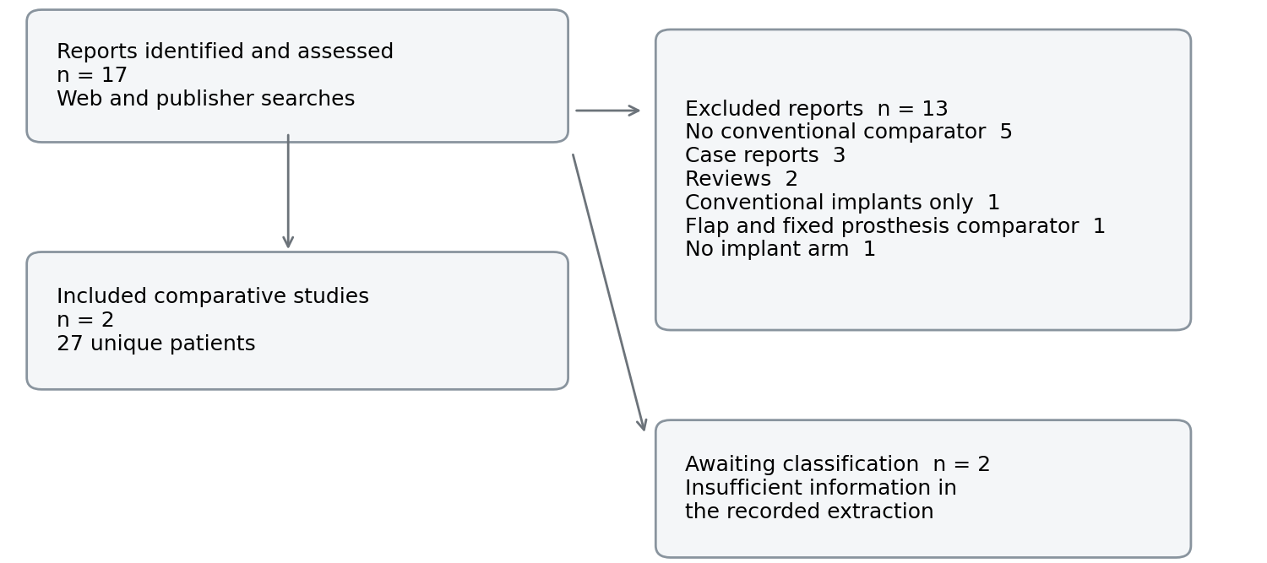

Figure 1. Selection of Reports Identified Through Other Methods

Flow summarizes the recorded 17 assessed reports. No structured database retrieval counts are available. Two reports remain unclassified in this evidence set; a retracted report is included among the exclusions. This is a PRISMA-informed flow for other identification methods.

Table 2. Excluded Reports and Reports Awaiting Classification
Report | Reason or status | Decision basis
Hussein 2025, Adv Dent J 7(2):133–46 [15] | Implant-supported obturators used conventional implants, not zygomatic implants | Full text
Wang 2017, Clin Oral Implants Res | Comparator was a fixed implant prosthesis on a free vascularized flap, not a conventional obturator | Title and publisher listing
Grover 2021, J Indian Prosthodont Soc 21(3):249–55 [19] | Compared conventional and customized obturators; no implant arm | Abstract
Vosselman 2024, Int J Oral Maxillofac Surg 53(7):600–6 [6] | No conventional obturator comparator | Publisher abstract
Kumar 2023, Clin Interv Aging 18:1201–19 [7] | No conventional obturator comparator | Full text
Diwakar 2026, Bioinformation 22(1):51–5 [17] | No conventional obturator comparator | Abstract and publisher page
Rajan 2024, J Maxillofac Oral Surg [18] | No comparator; case series | Publisher abstract
Mathevosyan 2024, Int J Implant Dent 10:31 [16] | No comparator; article retracted in July 2026 | Publisher page and retraction notice
Zygomatic implant-retained obturator, Case Rep Dent 2021 | Case report | Title and journal listing
Oncology zygomatic implant-retained obturator in a paediatric patient, Int J Implant Dent 2017 | Case report | Title and journal listing
Zygomatic implants for stabilization of obturator prostheses, J Oral Med Oral Surg 2020 | Case report | Title and journal listing
Hackett 2021, Oral Dis 27(1):27–41 [5] | Review; checked for comparative studies | Repository abstract
Kőnig 2025, J Prosthet Dent 133(1):305–14 [4] | Review of obturation versus surgical reconstruction; checked for comparative studies | Abstract record
Rehabilitation of maxillectomy patients using zygoma implants, 2025 (PMID 40756924) | Awaiting classification: full text not obtainable; design and comparator unconfirmed | Title only
Quality of life in oncologic patients after maxillectomy: case series on different rehabilitation protocols, 2024 (PMID 38639511) | Awaiting classification: full text not obtainable; unclear whether zygomatic and conventional obturator groups are reported separately | Title only

The final two reports were awaiting classification in the recorded extraction. Decisions were based on different levels of report access; this table is not a full text only exclusion log.

Characteristics of Included Studies
Salem and colleagues reported a prospective within-patient comparison from Egypt involving eight partial palatomaxillectomy patients [13]. Each used a conventional hollow obturator and subsequently received one implant in the zygomatic bone, followed by delayed connection to an implant retained obturator. The extraction reports 12 months of assessment for each prosthetic condition and a six month osseointegration interval. The precise relationship between implant insertion and the conventional obturator observation period was not consistently described in the extraction and is not assumed to represent an additional six months beyond that period. Outcomes included OHRQoL, masticatory muscle electromyography and abutment tooth health.
Buurman and colleagues compared 19 edentulous maxillectomy patients in the Netherlands [14]. Nine had implant supported obturators and ten conventional obturators. Implants were described in the remaining midfacial or skull-base bone; outcomes specific to zygomatic implants were not separable in the extraction. This study was therefore retained as indirect evidence. Outcomes included an objective mixing ability test and OHIP-EDENT, OFS and LORQv3 patient reports. Tables 3 and 4 summarize study characteristics and the available intervention details.

Table 3. Characteristics of Included Comparative Studies
Study and setting | Design and patients | Population and comparison | Follow-up and outcomes
Salem 2015 [13]  Egypt | Within-patient before-and-after; eight unique patients; five female, three male; age 20–58 years | Partial palatomaxillectomy; conventional hollow obturator followed by one zygomatic implant retained obturator per patient | 12 months per prosthetic condition reported; OHRQoL, EMG and abutment teeth
Buurman 2020 [14]  Netherlands | Comparative cross-sectional; 19 patients: nine implant supported, ten conventional | Edentulous maxillectomy; midfacial/skull-base implant sites not separated for zygomatic-specific outcomes | Single assessment after completed treatment; mixing ability, OHIP-EDENT, OFS, LORQv3

Table 4. Interventions and Outcome Measurement
Study | Implant and prosthesis details | Measurement and analytical limitations
Salem 2015 | One implant in zygomatic bone per patient; six month osseointegration period; conventional hollow prosthesis assessed first; system and attachment not established in extraction | OHRQoL instrument incompletely described; chewing EMG in µV; paired observations; change variance/correlation unavailable
Buurman 2020 | Obturator supported by implants in midfacial/skull-base bone; implant systems, numbers and zygomatic-specific subgroup not established in extraction | Objective mixing ability; OHIP-EDENT, OFS and LORQv3; between-group comparison; numerical results absent from extraction

EMG = electromyography; OHRQoL = oral health related quality of life; OHIP-EDENT = Oral Health Impact Profile for edentulous people; OFS = Obturator Functioning Scale; LORQv3 = Liverpool Oral Rehabilitation Questionnaire version 3.

Risk of Bias
Both studies were rated at serious risk of bias (Table 5 and Figure 2). In Salem 2015, the conventional prosthesis was always assessed first, allowing adaptation, healing and time to confound the change in treatment. Self reported outcomes were unblinded, and recruitment details were limited. In Buurman 2020, treatment was not assigned randomly and defect characteristics, radiotherapy or time since surgery could influence both treatment selection and outcomes. The record did not establish adequate control for these confounders.

Table 5. ROBINS I Assessments
Domain | Salem 2015 | Buurman 2020
Confounding | Serious: fixed prosthesis order; adaptation, healing and passage of time may confound comparison | Serious: no allocation; groups may differ in defect size, radiotherapy and time since surgery; no adjustment
Selection of participants | No information: recruitment method not reported | Moderate: patients with completed treatment only
Classification of interventions | Low | Low
Deviations from intended interventions | Low | Low
Missing data | Low: all 8 patients assessed | No information
Measurement of outcomes | Serious for OHRQoL: self-reported by unblinded patients; moderate for EMG | Moderate: objective mixing test; self-reported questionnaires by unblinded patients
Selection of the reported result | Moderate in the source assessment; prespecification not verifiable | Moderate in the source assessment; prespecification not verifiable
Overall | Serious | Serious

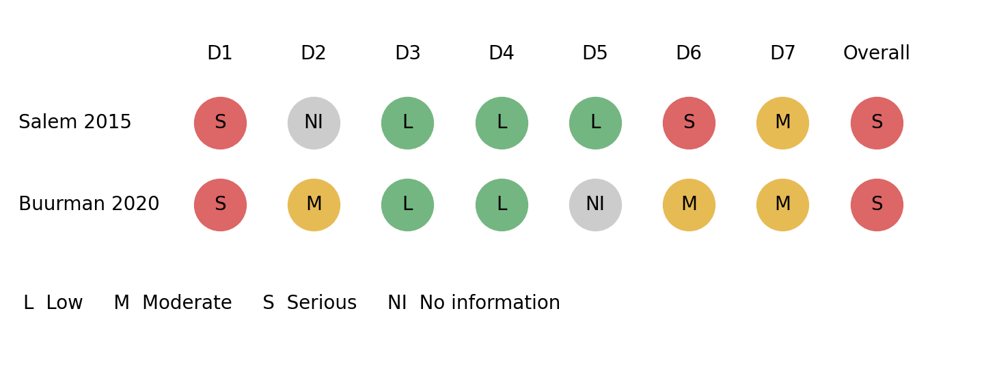

Figure 2. Risk of Bias Judgments by Domain

D1 confounding; D2 participant selection; D3 intervention classification; D4 deviations; D5 missing data; D6 outcome measurement; D7 reported result selection. Judgments are the recorded single-reviewer assessments. Salem’s outcome measurement judgment is serious for OHRQoL and moderate for EMG; the display uses the OHRQoL judgment.

Retention
Neither included study provided a direct objective retention measurement or a dedicated retention scale in the extraction. Improvements in chewing comfort cannot be equated with a measured increase in dislodging resistance. No comparative effect on retention was therefore estimated.

Quality of Life
Both studies reported favorable outcomes with implant support, but they did not provide equivalent evidence for a zygomatic-specific effect. Salem 2015 reported a mean OHRQoL impact score of 0.519 ± 0.168 with the conventional obturator and 0.173 ± 0.187 with the zygomatic implant retained obturator, a descriptive reduction of 0.346 score units (reported p < 0.01) [13]. The baseline score without an obturator was 2.55 ± 0.392; this baseline was not the comparator for the review question. The questionnaire identity and validation were incompletely described in the extraction, limiting clinical interpretation of the numerical change. Buurman 2020 reported better selected oral function, chewing difficulty and eating discomfort outcomes with implant support [14]; numerical group results were absent from the extraction. This finding does not establish that every questionnaire total improved. Table 6 presents the available outcomes.

Masticatory Function
Salem 2015 reported masseter activity of 115.4 ± 26.0 µV with the zygomatic obturator versus 62.0 ± 20.3 µV with the conventional obturator, a descriptive difference of +53.4 µV (reported p = 0.003). Temporalis activity was 144.1 ± 42.0 versus 62.25 ± 15.09 µV, a difference of +81.85 µV (reported p = 0.002) [13]. Electromyographic activity is a physiological surrogate and does not alone measure chewing efficiency or patient benefit. Buurman 2020 reported better objective mixing ability with implant support, although means and dispersion were absent from the extraction [14]. Figure 3 displays the numerical within-patient observations without an assumed paired correlation.

Implant Survival and Abutment Teeth
All eight zygomatic implants in Salem 2015 osseointegrated, and none failed during 12 months of loading [13]. There were no significant differences between prostheses in gingival index, tooth mobility or bone loss around the abutment teeth. Buurman 2020 did not report implant survival in the accessible report [14].

Speech and Complications
The extraction did not provide comparative speech, surgical complication or prosthetic complication data. These outcomes cannot be interpreted as showing no difference or no complications.

Table 6. Extracted Outcome Results
Outcome | Study | Implant obturator | Conventional obturator | Reported findings
Retention (objective or dedicated scale) | Both studies | Not measured | Not measured | No data
OHRQoL impact score, mean ± SD (lower is better) | Salem 2015 | 0.173 ± 0.187 | 0.519 ± 0.168 | Favours implant obturator; p < 0.01
OHIP-EDENT, OFS and LORQv3 | Buurman 2020 | Group means absent from extraction | Group means absent from extraction | Better oral function, fewer chewing difficulties and less eating discomfort with implant obturator; statistically significant
Masseter EMG amplitude, µV, mean ± SD | Salem 2015 | 115.4 ± 26.0 | 62.0 ± 20.3 | Favours implant obturator; p = 0.003
Temporalis EMG amplitude, µV, mean ± SD | Salem 2015 | 144.1 ± 42.0 | 62.25 ± 15.09 | Favours implant obturator; p = 0.002
Masticatory performance (mixing ability test) | Buurman 2020 | Group means absent from extraction | Group means absent from extraction | Favours implant obturator; statistically significant
Implant survival | Salem 2015 | 8 of 8 implants at 12 months | Not applicable | No failures
Abutment teeth (gingival index, mobility, bone loss) | Salem 2015 | Reported | Reported | No significant difference

Means are shown with standard deviations. Salem’s conditions involve the same eight patients. P values are transcribed from the extraction and were not recalculated; no paired confidence interval is available. No prosthesis baseline OHRQoL score: 2.55 ± 0.392.

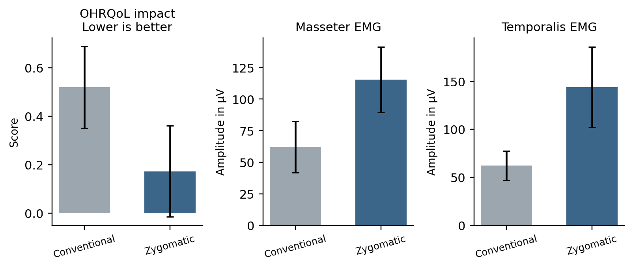

Figure 3. Reported Mean Outcomes in the Eight Patient Comparison

Salem 2015 [13]. Bars show reported means and error bars show standard deviations, not confidence intervals. The same eight patients contributed to both conditions. Lower OHRQoL impact is favorable; EMG is a physiological surrogate. The panels use different units and must not be interpreted as independent studies or combined effects.

Certainty of Evidence
For outcomes with comparative observations, the available evidence was rated very low certainty because of serious bias, indirectness and small samples. Retention had no direct comparative measurement. Implant survival was observed in one small treated cohort and does not estimate a relative effect against conventional obturation. Table 7 records the outcome-specific findings.

Table 7. Summary of Findings and Certainty
Outcome | Evidence base | Findings | Certainty | Limitations
Retention | 0 | No direct retention measure in included comparisons | No evidence | Not applicable
Oral health-related quality of life | 2 (27) | Both studies favour implant-retained obturators; effect size available for one study only | Very low | Risk of bias (serious in both); indirectness (implant sites not separated in one study); imprecision (27 patients)
Masticatory function | 2 (27) | Higher muscle activity and better mixing ability with implant-retained obturators | Very low | Risk of bias; indirectness (surrogate EMG outcome); imprecision
Implant survival | 1 (8 implants) | 8 of 8 implants survived at 12 months | Very low | Risk of bias; imprecision (single small study)

Population: patients rehabilitated after maxillectomy. Direct intervention: zygomatic implant retained obturator. Conventional removable obturator comparator. Buurman’s broader implant supported comparison is indirect. Twenty-seven denotes unique patients, not 35 independent prosthesis observations.

DISCUSSION

Principal Findings
The current evidence set contains two small nonrandomized comparisons involving 27 patients. Direct evidence for zygomatic anchorage comes from eight patients; the remaining 19 provide broader implant support evidence. Reported OHRQoL and masticatory findings favor implant support, but both studies have serious risk of bias and certainty is very low. Retention was not directly measured, comparative harms were inadequately reported and pooling was not justified.

Interpretation
The findings are compatible with the rationale that additional bony anchorage can reduce dependence on residual teeth, soft tissues and defect undercuts [2,3]. However, that mechanism was not tested through direct retention measurements in the included comparisons. Increased electromyographic activity may reflect altered recruitment during chewing, while improved patient reports may reflect comfort, adaptation or other aspects of rehabilitation. Neither result identifies retention as the causal pathway.
The size of the benefit cannot be estimated reliably from these data. In Salem 2015, the implant obturator was always the second prosthesis, so part of the improvement may reflect adaptation, healing and experience with obturator use rather than retention [13]. In Buurman 2020, patients chose or were offered implants for clinical reasons that may also influence function and quality of life [14].

Comparison with Other Studies
Single-arm studies provide contextual evidence on feasibility and implant survival, but they do not estimate the added benefit over a conventional obturator. The oncology review described survival ranging from 77% to 100% [5]. Prospective reports addressed guided placement in head and neck cancer patients [6] and rehabilitation after mucormycosis-related maxillectomy [7]. Other clinical series addressed functional outcomes [17]. Differences in underlying disease, irradiation, anatomy and prosthesis design limit comparisons across these reports. Their survival observations should not be combined with comparative quality of life findings as evidence of route or prosthesis superiority.
A conventional implant study reported favorable selected OFS outcomes with implant supported obturators [15], but conventional implants are not equivalent to zygomatic anchorage. A separate systematic review compared obturation with surgical reconstruction [4], addressing a different decision from the present review. These adjacent evidence bases provide context but cannot establish that the retention method matters more than the choice of surgical versus prosthetic reconstruction.

Strengths and Limitations
The synthesis uses explicit eligibility criteria, separates direct zygomatic evidence from broader implant comparisons and distinguishes comparative findings from uncontrolled survival data. It reports outcomes that were not measured and avoids pooling different constructs. The paired design of Salem 2015 is preserved by declining to manufacture confidence intervals from an independence assumption.
Search coverage is the main review-process limitation. Bibliographic databases were not systematically searched, reference lists were not comprehensively screened and two reports remained unclassified in the recorded extraction. Targeted citation checks do not resolve those gaps. One reviewer undertook study selection, extraction and risk of bias assessment, increasing vulnerability to missed studies, transcription errors and subjective judgments. The screening counts describe assessed reports and should not be interpreted as complete database retrieval counts.
Evidence limitations include small samples, lack of random allocation, fixed treatment order in the within-patient comparison, uncertain confounding control and an incompletely described OHRQoL instrument. The broader implant comparison cannot isolate the effect of zygomatic fixtures. Missing paired variance and incomplete arm level numerical data limit estimation of precision, while absent comparative complication reports prevent a complete benefit–harm assessment.

Implications for Practice
These findings support discussion of zygomatic anchorage as a possible rehabilitation option, but they do not support a general recommendation that it is superior to a conventional obturator. Clinical decisions require consideration of residual anatomy, disease status, radiotherapy, surgical suitability, maintenance needs and patient preferences. Comparative gains and harms remain uncertain. Implant survival in a small treated cohort is not sufficient evidence of overall safety or long-term benefit.

Implications for Research
Future comparative studies should use clearly defined defects, comparable patient groups and prespecified assessment intervals. Objective dislodging resistance, validated patient reported measures, speech, chewing performance, surgical complications and prosthetic maintenance should be reported separately. Within-patient designs should report the variance of paired changes and address order and adaptation effects. Follow-up should be long enough to assess survival and maintenance, with radiotherapy and disease cause reported. Complete search coverage and independent review are also needed to strengthen the present evidence synthesis.

CONCLUSION
Zygomatic implant retained obturators may improve OHRQoL and aspects of masticatory function after maxillectomy, but direct comparative evidence is limited to one eight patient nonrandomized study. A second study supports broader implant assisted rehabilitation and is indirect for the zygomatic-specific question. Neither establishes retention superiority, and comparative safety remains uncertain. Serious risk of bias, restricted searches and incomplete quantitative reporting result in very low certainty. No meta-analysis was undertaken.

REFERENCES
- Brown JS, Shaw RJ. Reconstruction of the maxilla and midface: introducing a new classification. Lancet Oncol. 2010;11(10):1001–8. doi:10.1016/S1470-2045(10)70113-3
- Aramany MA. Basic principles of obturator design for partially edentulous patients. Part I: classification. J Prosthet Dent. 1978;40(5):554–7.
- Kornblith AB, Zlotolow IM, Gooen J, Huryn JM, Lerner T, Strong EW, et al. Quality of life of maxillectomy patients using an obturator prosthesis. Head Neck. 1996;18(4):323–34.
- Kőnig J, Kelemen K, Váncsa S, Szabó B, Varga G, Mikulás K, et al. Comparative analysis of surgical and prosthetic rehabilitation in maxillectomy: a systematic review and meta-analysis on quality-of-life scores and objective speech and masticatory measurements. J Prosthet Dent. 2025;133(1):305–14. doi:10.1016/j.prosdent.2023.11.023
- Hackett S, El-Wazani B, Butterworth C. Zygomatic implant-based rehabilitation for patients with maxillary and mid-facial oncology defects: a review. Oral Dis. 2021;27(1):27–41. doi:10.1111/odi.13305
- Vosselman N, Kraeima J, Ng Wei Siang K, Raghoebar GM, Witjes MJH, de Visscher SAHJ. Guided placement of zygomatic implants in head and neck cancer patients: implant survival and patient outcomes at 1–3 years of follow-up. Int J Oral Maxillofac Surg. 2024;53(7):600–6. doi:10.1016/j.ijom.2024.03.001
- Kumar L, Verma A, Pal US, et al. Influence of prosthodontic rehabilitation using zygomatic implants in Covid 19 related mucormycosis (rhino-orbital-cerebral) maxillectomy patients upon post-operative stress, anxiety and functional impairment: a prospective cohort study. Clin Interv Aging. 2023;18:1201–19. doi:10.2147/CIA.S412625
- Page MJ, McKenzie JE, Bossuyt PM, Boutron I, Hoffmann TC, Mulrow CD, et al. The PRISMA 2020 statement: an updated guideline for reporting systematic reviews. BMJ. 2021;372:n71. doi:10.1136/bmj.n71
- Higgins JPT, Thomas J, Chandler J, Cumpston M, Li T, Page MJ, et al., editors. Cochrane Handbook for Systematic Reviews of Interventions. Version 6.4 (updated August 2023). London: Cochrane; 2023.
- Sterne JAC, Hernán MA, Reeves BC, Savović J, Berkman ND, Viswanathan M, et al. ROBINS-I: a tool for assessing risk of bias in non-randomised studies of interventions. BMJ. 2016;355:i4919. doi:10.1136/bmj.i4919
- Campbell M, McKenzie JE, Sowden A, Katikireddi SV, Brennan SE, Ellis S, et al. Synthesis without meta-analysis (SWiM) in systematic reviews: reporting guideline. BMJ. 2020;368:l6890. doi:10.1136/bmj.l6890
- Guyatt GH, Oxman AD, Vist GE, Kunz R, Falck-Ytter Y, Alonso-Coello P, et al. GRADE: an emerging consensus on rating quality of evidence and strength of recommendations. BMJ. 2008;336(7650):924–6. doi:10.1136/bmj.39489.470347.AD
- Salem AA, Shakel EA, Sadakha AA, Kassem EM, El-Segai AA. Evaluation of zygomatic implant retained obturator in rehabilitation of partial palato-maxillectomy patients. Tanta Dent J. 2015;12(1):35–40. doi:10.1016/j.tdj.2014.10.003.
- Buurman DJM, Speksnijder CM, Engelen BHBT, Kessler P. Masticatory performance and oral health-related quality of life in edentulous maxillectomy patients: a cross-sectional study to compare implant-supported obturators and conventional obturators. Clin Oral Implants Res. 2020;31(5):405–16. doi:10.1111/clr.13577
- Hussein SK, ElKhashab MA. Oral-health related quality of life of implant supported obturator prosthesis versus conventional obturator in hemimaxillectomy patients. Adv Dent J. 2025;7(2):133–46. doi:10.21608/adjc.2024.276432.1503
- Mathevosyan D, Hovhannisyan S, Mashinyan K, Khachatryan L, Badalyan AV, Hakobyan G. Prosthetic rehabilitation of patients with maxillary oncology defects using zygomatic implants. Int J Implant Dent. 2024;10:31. doi:10.1186/s40729-024-00545-y. Retracted 13 July 2026; retraction notice doi:10.1186/s40729-026-00704-3.
- Diwakar JK, Fatima T, Naik SS, Lau M, Singh VD, Dixit A. Functional and esthetic outcomes of zygomatic implant-supported prosthesis in post-maxillectomy patients: a clinical evaluation. Bioinformation. 2026;22(1):51–5.
- Rajan G, Obla Ramesh A, Krishnamurthy S, et al. Zygomatic implant-based rehabilitation in post-COVID maxillary mucormycosis defects: a case series. J Maxillofac Oral Surg. 2024. doi:10.1007/s12663-024-02130-7
- Grover R, Jurel SK, Agarwal B, et al. Speech intelligibility, nasal resonance, and swallowing ability of maxillectomy patients with customized obturator: a non randomized controlled study. J Indian Prosthodont Soc. 2021;21(3):249–55. doi:10.4103/jips.jips_98_21

